To: The Chief Constable, [Police station]
To use the links in this documents, please download from:
https://TheUKofLove.com/bluetoothfreedom/
RE: COMPENSATION CLAIM IN CONNECTION WITH THE ILLEGAL INSTALLATION OF A BLUETOOTH OPERATIONAL TELECOMMUNICATION SYSTEM INSIDE THE BODY THROUGH THE COVID VACCINE
Dear Sir/Madam,
With the following letter, I’d like to inform you that I have been subject to a medical experiment without my knowledge and consent by [name of vaccine producer] through their Covid vaccine. I have detected a Bluetooth signal that’s being emitted by my body after my Covid-19 vaccination. This Bluetooth signal can be detected with the following mobile phone apps:
For Android: “Bluetooth Scanner - Bluetooth finder - pairing ” by Zoltan Pallagi (recommended), “Microchip Bluetooth Data”, “Find My Bluetooth Device”, “Free EMF Detector, EMF Meter – ElectroSmart”, a.o.
For iPhone: ”Bluetooth BLE device” (recommended), “BLE Scanner 4.0”, “Find My Bluetooth Device Pro”, “Find My Bluetooth Device” or “Scanner Bluetooth a.o.
For the identification of the source of the Bluetooth signal I used the elaborated Protocol For Detecting Bluetooth Signal In Vaccinated With Mrna Vaccines Against Covid By Using A Mobile Phone, which is a very clear and easy to understand and apply procedure by anyone. There is also a video tutorial on Bitchute.com: How to find the Bluetooth chip in vaccinated people .
There are numerous Bluetooth devices of the same type as mine that I have detected on a number of occasions anywhere in public spaces, which shows that clearly a considerable part of the vaccinated, most probably the vast majority carry such signal as well. The Bluetooth signal is detected and represented by these apps through their MAC addresses, but no descriptive name is given, which is not normal as every produced Bluetooth device comes with a descriptive name and more information.
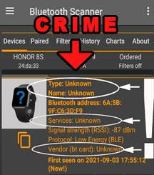
TRIPLE CHECK
A quick triple check confirms that these Bluetooth devices come with a MAC address which is unregistered and obviously is a criminal event by itself. I use for the test the “Bluetooth Scanner - Bluetooth finder - pairing ” app by Zoltan Pallagi (Android).
- INSIDE THE APP: The devices come up as: Type: UNKNOWN, Name: UNKNOWN, Services: UNKNOWN, and Vendor (bt card): UNKNOWN. Only the MAC address is displayed without any information about the devices. This is not ok, as every Bluetooth device has a name through which one can identify it and connect with it.
- ON INTERNET: A further check on the MAC address of the Bluetooth devices through websites of the sort of https://maclookup.app/ (MAC address verification websites) also confirms that there’s no information available about these devices. This is the same situation as if one enters a registration number of a car on a vehicle registration website and sees that there’s no information available on the type of vehicle, year of production, owner, MOT, insurance, tax, etc. In other words, these Bluetooth devices are as illegal and criminal as vehicles with fake registration numbers.
- BLUETOOTH INTERNATIONAL CLASSIFICATION: When pressing the MORE button of the app we get information on the device’s major class code, which is 7936. According to the international Bluetooth Special Interest Group classification this code means that these devices fall in the category of “laboratory probes”. This confirms that somebody has produced these devices without registering and clearly defining what their purpose is. Somebody has turned our living and working environment into an unidentified Bluetooth network “laboratory” with unknown purpose.
Every Bluetooth device producer is interested for the customer to easily find and connect with his devices, so he makes sure the devices appear on the standard Bluetooth search menu and they have clear, descriptive names and one can easily connect with them. Yet, these devices don’t appear on the standard Bluetooth menus of phones and do not have descriptive names, which is a further indicator that THE PRODUCER HAS CONSCIOUSLY HIDDEN THEM from the public and DOESN’T WANT ANYONE TO KNOW WHAT THESE DEVICES ARE AND WHAT THEIR PURPOSE IS!
Having such kind of illegal Bluetooth telecommunication devices around requires the following answers:
- What are these devices?  - What is their purpose? | - Who installed them?  - What is the motivation? | - What are the consequences?  - How to eliminate the crime?

Here, if you allow me, I’d like to help you with answering all the questions above.
- WHAT ARE THESE BLUETOOTH DEVICES?
These are the Bluetooth operational systems installed through the Covid injections in the vaccinated. Unfortunately, vaccinated people have been injected with such a system without their knowledge and consent. Anyone can identify the exact MAC address (chip number) of each carrier of such a signal in minutes with the help of a detailed and easy to use protocol by going on the Bluetooth Freedom Project page: https://theukoflove.com/bluetoothfreedom/. Further to this you can also see the video and the document from the Bluetooth microchip detection research done by a French group of scientists: https://operationxb.citizen-light.com/ , document: https://tiny.cc/vaxchip_scires. The Spanish doctor Dr Luis Benito reports that he has discovered the signal in 96 out of the tested 112 vaccinated patients.
The best summary of over 20,000 hours of research from teams from all over the world can be seen in Bitchute.com: LA QUINTA COLUMNA CONFIRMS WHAT’S IN THE VACCINE. A wonderful documentary also is "Blue Truth" .
Please, be informed that there are 1M+ users of the “Bluetooth Scanner - Bluetooth finder - pairing ” app mentioned here who in their feedback acknowledge the high quality and simplicity of use of the app. They use it mainly to find their lost wireless Bluetooth ear-buds and they do so in a matter of minutes. This means that ANYONE CAN REALLY IDENTIFY THE EXACT SOURCE OF ANY OF THESE DEVICES WITHIN MINUTES as long as one has the cooperation of the person carrying the device (see the protocol for details).
- PURPOSE OF THE BLUETOOTH DEVICES
As explained in incredible details and clarity in the video on Bitchute.com: LA QUINTA COLUMNA CONFIRMS WHAT’S IN THE VACCINE the purpose of these Bluetooth devices is to connect the human nervous system with the internet of things and transform the vaccinated into bio-robots without their own will where they will be subjected to complete biological, emotional and mind control from a distance through the telecommunication systems and AI. Another great video with in-depth explanations of the exact brain wave mechanisms of manipulation through this system is found here: Explanation of the MAC address phenomenon. Are vaccinated people hacked and controlled?
HUMANS ARE NOW HACKABLE ANIMALS
Yuval Noah Harari from the World Economic Forum : “In the past many governments wanted to do it, but no one understood biology well enough and no one had enough computing power and data to hack millions of people. Neither the Gestapo, nor the KGB could do it. But soon at least some corporations and governments will be able to systematically hack all the people. We humans will get used to the idea that we are no longer mysterious souls. We are now hackable animals…Data might enable elites to do something even more radical than just field physical dictatorships. By hacking organisms elites may gain the power to reengineer the future of life itself… Science is replacing evolution by natural selection with evolution by intelligent design, not by intelligent design of some god above the clouds, but our intelligent design”.
Yuval Noah Harari explain the great reset / transhumanism agenda;
Free will is over;
Covid Is Critical For People To Agree To Surveillance Under The Skin;
"Meaningless, Worthless People"
- WHO INSTALLED THESE DEVICES?
While it is clear that the vaccine producers have inserted the graphene oxide nano-technology in the vaccines there are other people as well who are involved in this initiative. These are the leaders of the so-called New World Order who openly declare their plans of chipping the population with the proclaimed intent to optimise the health system in society and introduce the new 4th human revolution, which will be a revolution of how we see the world, how we do things and how we transform ourselves.
- WHAT IS THE MOTIVATION OF THE PEOPLE WHO INSTALLED THESE BLUETOOTH DEVICES?
The motivations can be best understood from the video explaining in details the whole operational system installed in the bodies of the vaccinated LA QUINTA COLUMNA CONFIRMS WHAT’S IN THE VACCINE, but also directly from Yuval Noah Harari one of the main consultants to Klaus Schwab, the leader of the World Economic Forum, which is a key organisation through which the plans for The New World Order are being developed and implemented. The motivation is to put into a COMPLETE ELECTRONIC PRISON all the future generations on the planet and divide the society into masters who run this electronic Matrix and slaves who being bio-robots are completely incapable of having their own will as everything from their biology, through their emotions and mind is being programed through computer algorithms managed by AI and serving the needs of the owners of the private corporations that are secretly introducing these technologies in the society under the disguise of antiviral vaccines and other means. More on this in the Bluetooth Freedom Project document.
The catastrophic amount of deaths and injuries caused by the vaccines due to the high toxicity of the graphene oxide and the negative side effects from the spike proteins and whole bunch of other non-disclosed materials in the vials like chromium, nickel, sulphur, chloride, nitrogen, bismuth, titanium, vanadium, iron, copper, silicon and aluminium, the carcinogenic and genotoxic Poly-ethylene glycol (PEG) and ethylene alcohol and also parasites inevitably lead to the conclusion that there’s an additional motivation to the attack on humanity disguised as health measures against COVID and this motivation is DEPOPULATION. Those who closely follow the writings and speeches of the leaders of The New World Order have found many quotes and evidence that point to the intent of this group to bring the world population down to a manageable limit of below 1 billion people.
- WHAT ARE THE CONSEQUENCES?
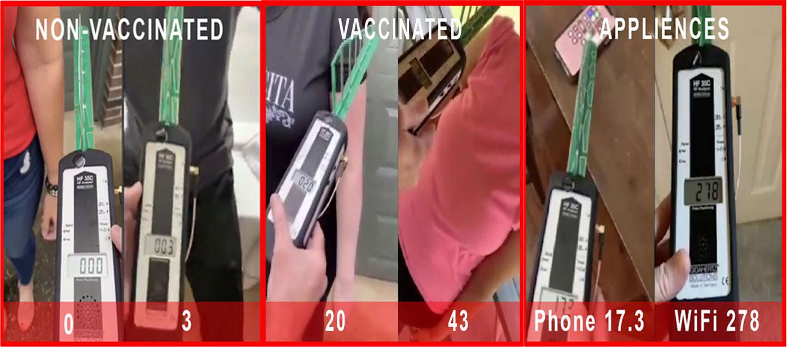
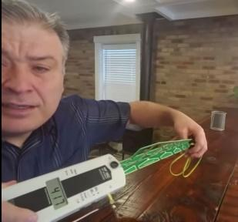
  - CONSTANT 24/7 BLUETOOTH RADIATION (2.4 GHZ) EMISSIONS FROM THE BODY
Bluetooth devices emit RF radiation. There have been hundreds of peer reviewed studies on RF radiation and its harmful effects since 1960. The article Is Bluetooth Radiation Dangerous? from the website https://www.radiationhealthrisks.com throws light on the real and unsuspected dangers of the Bluetooth type of RF radiation. Youtube video with a demo: How Much Radiation Do Cellphones & Bluetooth Earbuds Emit?
In the BREAKING: HIGH FREQUENCY VAXED PEOPLE video on Bitchute there are real life measurements done with professional equipment for evaluating the RF radiation of vaccinated people. While the device measured 0 to 3 with non-vaccinated the indications with vaccinated are 20 to 43. For comparison, the mobile phone on the video gave a measure of 17.3 and the WiFi router 278. The HARMFUL RF RADIATION emitted from the bodies of the vaccinated people IS REAL.
RF radiation is proven to cause cancer, DNA damage (especially in infants and fetuses), crib death, male infertility, autism, heart problems, heart palpitations, heart arrhythmias, leg cramps, vertigo (balance problems), sleeping disorders, headaches, ringing in the ears, eye problems a.o.
  - DANGEROUS COMBINATION BETWEEN 5G AND GRAPHENE OXIDE INSIDE THE VACCINATED
5G all by itself is already a life threatening influence in our environment (a must watch video on 5G: 5G APOCALYPSE – THE EXTINCTION EVENT by Sacha Stone). When 5G activates the graphene oxide inside the bodies of the vaccinated it can lead to unpredictable consequences. On one hand the level of radiation of the vaccinated will be higher and on the other graphene oxide can become “alive” and move and take different shapes as seen on many demo videos (more on this in the Bluetooth Freedom Project book).
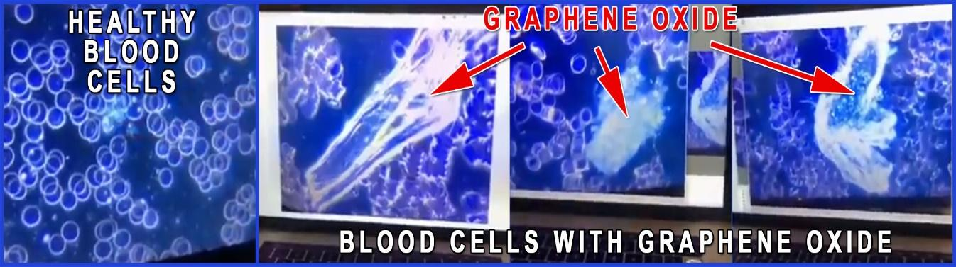
  - HIGH TOXICITY OF THE GRAPHENE OXIDE
The effects of the graphene oxide on the health of the blood can be seen and understood by everyone when looked under a microscope.
Healthy blood cells have nice round shapes (indication of good health of the cell), they have large space between them and move freely around. The blood cells contaminated with graphene oxide are deformed (sign of bad health of the cell), they are coagulated (stacked together in groups) and their movement is strongly impaired. Naturally, an organism with such a kind of blood disorder will be subjected to low oxygen levels and all abnormalities coming from the poor condition of the blood.
Graphene oxide causes anything from headache and smell loss to serious nervous disorders, cancer, DNA damage, leukaemia, infertility, pulmonary fibrosis, mitochondrial damage, stem cells damage, gut damage, testis damage, blood clots leading to heart attacks and others. Perhaps the largest body of studies done on the toxicity of graphene oxide can be found on the page of the Spanish research website La Quinta Columna. Here’s a list of about 60 publications done on the toxicity of graphene oxide in the human body.

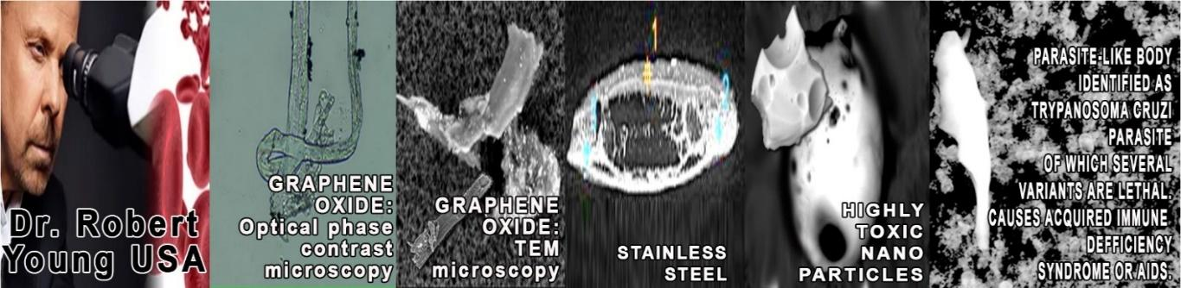
  - ADVERSE EFFECTS FROM OTHER NON-DISCLOSED SUBSTANCES IN THE VACCINES
Official data has shown that there are more adverse effects from the COVID vaccines compared to all vaccines in the last 30 years taken together. They are due to the graphene oxide, the toxicity of the spike protein and the impact of all other non-disclosed substances. Shockingly, there were also parasites observed in the vials of Pfizer and Moderna. Dr. Bryan Ardis presented a series of evidence for the presence of synthesised king cobra’s venom in the vaccines (WATCH THE WATER).
A most thorough microscopic study using different techniques for spectrum analysis was conducted by the world renowned scientist Dr. Robert Young. Dr. Young was able to identify not only the graphene oxide, but also parasites and a whole bunch of other non-disclosed materials like chromium, nickel, sulphur, chloride, nitrogen, bismuth, titanium, vanadium, iron, copper, silicon and aluminium. The presence of the carcinogenic and genotoxic Poly-ethylene glycol (PEG) and ethylene alcohol was also registered. The research document can be found on Dr. Young’s website , or as a video discussion on Bitchute.com. Numerous more independent studies on the contents of the vials can be seen in the Bluetooth Freedom Project book.
  - COMPLETE BODY, HEALTH, EMOTION AND MIND CONTROL
By connecting the Bluetooth microchip operating system in the body with the mobile phones, the telecommunications systems and AI all vaccinated individuals are exposed to a complete body, mind and emotions control by the private corporations who have installed these operating systems. The vaccinated now are practically bio-robots owned by the corporations. This new type of social development in the world is openly supported by Yuval Noah Harari from The World Economic Forum, a close associate to Claus Schwab, who is the mind-master of this organisation (Yuval Noah Harari explain the great reset / transhumanism agenda; Free will is over , Covid Is Critical For People To Agree To Surveillance Under The Skin, Yuval Noah Harari Calling the Masses "Meaningless, Worthless People" ). Having in mind that these leaders believe in the depopulation agenda where the majority of the world population is “meaningless and worthless” it isn’t hard to guess what will the corporations do with this newly acquired power over the bodies and minds of people. The most probable use of this Bluetooth connection will be to create a series of believes, emotions, biological and social conditions and circumstances that will naturally lead to the extinction of the vast majority of the vaccinated and wouldn’t allow their reproduction to keep down the numbers of these “meaningless and worthless” bio-units on the planet that they believe that they own. Anything from any kind of mood, through any kind of disease and creating events on a larger social level becomes available at their fingertips as a computer game. Now they can commit even mass murder from a distance and get away with it as long as people are completely unaware of this Bluetooth biological operational system (see real life example in the Bluetooth Freedom Project book, attachment 5).
TO SUMMARIZE HERE IS A VISUAL OF WHAT ACTUALLY THIS BLUETOOTH MAC ADDRESS MEANS.
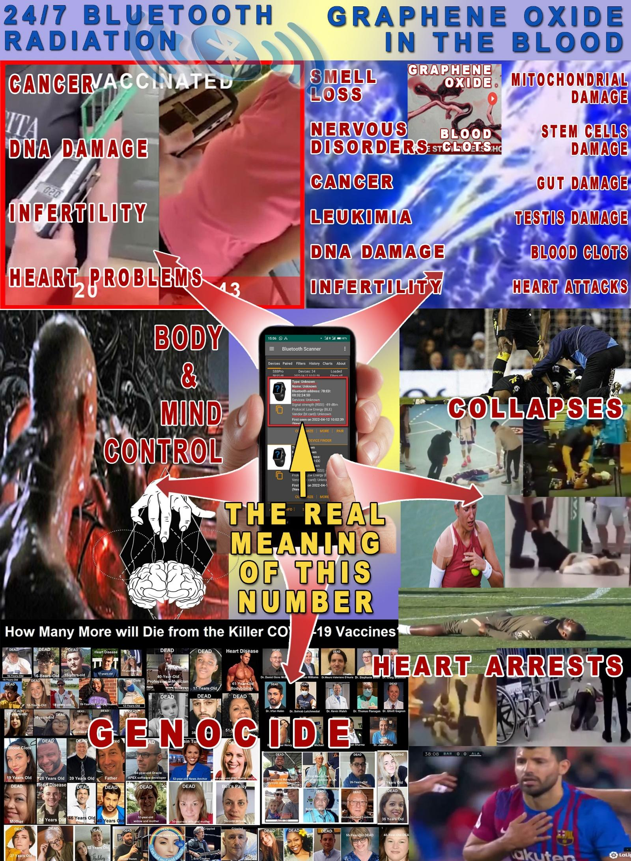

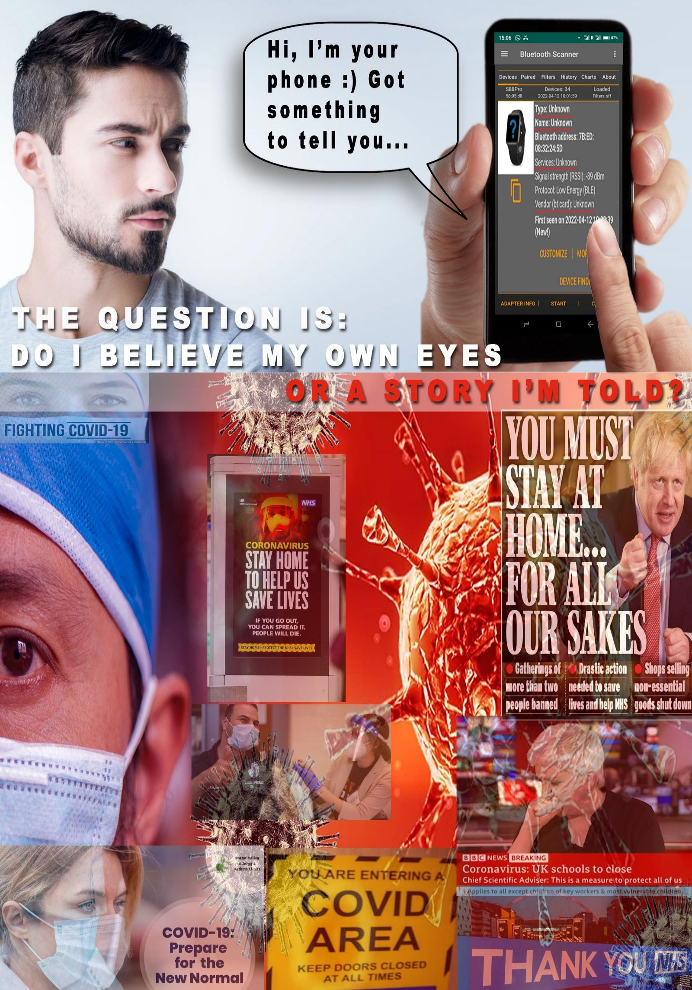
A VISUALISATION ABOUT THE DILEMMA: DO WE TRUST THE STORIES WE’VE HEARD OR OUR OWN EYES AND PHONES..
TECHNICAL DETAILS
When testing on different occasions for the Bluetooth signal emitted from my body I noticed that there are different MAC addresses at different times just as mentioned in the protocol for detection. It looks like the producers of this Bluetooth operational system are trying to confuse anyone who might try to track down these devices. This though doesn’t affect the test result. Here is the comment from the protocol about the observed change of MAC addresses:
“IMPORTANT NOTE 2: While with standard Bluetooth devices the MAC addresses are constant and do not
change, the Bluetooth devices of the vaccinated can change over time, ie. they may not be permanent. In the
technical literature, this is known as spoofing - changing the MAC address. The reason for these variations is not
known yet. The number may change, but the signal from the body remains constant and constantly generates
new MAC addresses. The interval of change of these MAC addresses is also not specified yet, but it is at least a
few hours or perhaps daily, which allows the test to be done successfully when using the same MAC address. The
variations in these addresses do not affect the test results described in this protocol in any way. What remains
constant is the presence of MAC addresses of unknown type and also the signal strength measured by the graph.”
MY COMPENSATION CLAIM
In view of all presented evidence, I’d like to place a compensation claim for the fact that my body has been illegally used as a subject of a medical experiment without my knowledge and consent.
In view of the extreme simplicity, accessibility and speed of acquiring the proof of my claim by anyone who has a smartphone and has the most basic capacity to use any application, which takes literally minutes as it is in the standard case of the 1 million + users of the app who locate the source of the Bluetooth signal of their lost Bluetooth devices in minutes, I’m looking forward to a transparent and speedy investigation process and decision.
Sincere gratitude for your professional and responsible attention to this case.
Kind regards,
[ Signed ]
Date,
………

ATTACHMENTS:
- Snapshot(s) (Videos) of the tests I’ve done to confirm that the source of the Bluetooth signal is located inside my body.
- Protocol for detecting Bluetooth signal in vaccinated with mRNA vaccines against Covid by using a mobile phone.
- Study of the presence of Bluetooth signals in vaccinated, France: Project Bluetooth experience X (available in the Bluetooth Freedom Project book).
- Independent laboratory tests from around the world for graphene oxide and other non-declared substances in covid vaccines (the Bluetooth Freedom Project book).
To use the links in this documents, please download from:
https://TheUKofLove.com/bluetoothfreedom/

